Demonstrating Success:
A Technical Assistance Guide for Collecting Postexit Indicators

Contents
Page
1. Introduction 1
Overview of the Guide 1
2. Postexit Indicator Definitions and Calculations 2
Employment Rates 2
Median Earnings 3
Credential Attainment 4
The Impact of Missing Data in Indicator Calculation 6
3. Steps for Collecting Postexit Employment and Credential Indicators 6
Step 1: Create the Participant Pool for Each Indicator (Denominators) 7
Step 2: Determine Time Periods for Data Collection 9
Step 3: Collecting the Data to Determine Achievement for Indicators (Numerators) 11
Step 4: Reporting Results 12
4. Strategies for Improving Data Quality 13
Data Matching 16
Supplemental Data Collection 17
Strategies for Improving Data Collection Through Surveys 17
Reducing Burden: Organize the Survey Process 21
Other Supplemental Methods for Employment Indicators 22
Conclusion 23
Appendix. Sample Survey Questions 27

Exhibits
Page
Exhibit 1. Calculating the Employment Indicators 3
Exhibit 2. Calculating Median Quarterly Earnings 4
Exhibit 3. Calculating the Credential Indicator Rate 5
Exhibit 4. Participant Pools for Indicator (Denominators) 8
Exhibit 5. Data Collection by Indicator and Exit Quarters, for PY 2018 (Reporting on October 1, 2019) 10
Exhibit 6. Participant Exit Periods for Reporting Postexit Indicators 11
Exhibit 7. Strategies for Improving Collection of SSNs 15
Exhibit 8. California’s Plans for Improving Data Collection with Surveys 20
Exhibit 9. Strategies for Improving Data Collection with Surveys 22
Exhibit 10. Planning Worksheet for Collecting Postexit Indicators 24

1. Introduction
The purposes of adult education described in the Workforce Innovation and Opportunities Act (WIOA) include assisting adults in acquiring the basic literacy and language skills needed to be productive citizens, obtain employment, and prepare for further education. WIOA embodies these purposes in the performance indicators—described in Section 116 of the Act—of second- and fourth-quarter employment, median earnings, attainment of credentials and measurable skill gains (MSGs). Except for MSG, these indicators are captured after participants exit the program. Through these indicators, WIOA firmly places adult education as the cornerstone of a broader system of workforce and educational development to prepare low-skilled adults for the challenges they face in employment and further education after exiting the program. Performance on the postexit indicators demonstrates the success of programs in preparing participants for these challenges.
Collecting the data for the indicators is new to adult education and poses many challenges to states. The process begins at participants’ entry, when programs collect Social Security numbers (SSNs) to allow states to track participants after exit. In addition, programs must gather participant demographics, including measures of their barriers to employment, which are also new data elements required under WIOA. Following program exit, states and programs must develop approaches to track students through employment and postsecondary databases, surveys, or other methods to determine achievements on the indicators.
The process of tracking and collecting data on participants who are no longer enrolled poses a significant resource burden on states and programs. Not all participants will provide SSNs, and programs may lose contact with participants. States must build their data and tracking systems to accommodate the WIOA indicators and develop agreements with other agencies to access databases. In some states, data matching is not possible or only incomplete data are available, necessitating the use of supplemental data collection. States must also provide training and ongoing professional development to ensure that local program staff understand the indicators, new data systems, and data collection requirements.

Overview of the Guide
This guide serves as a technical assistance resource for state and local staff to understand the postexit indicators and suggests ways to improve the quality of these data. It explains the indicators and how they are collected and calculated and provides guidance to help states and programs overcome the many challenges they face in collecting these data. The guide provides approaches to enhance the completeness and quality of data in each step of the data collection process.
Section 2 of the guide defines each indicator, explains how each is calculated for reporting and performance accountability, and discusses the impact of missing data. Section 3 details four major steps involved in collecting the indicators: creating the pool of participants to whom the indicators apply, determining the time periods when the data need to be collected, applying the data collection procedures, and reporting the indicator data to the U.S. Department of Education’s Office of Career, Technical, and Adult Education (OCTAE). In Section 4, we offer strategies for improving data quality. This section suggests ways to improve the process of obtaining SSNs from participants, strategies for maintaining contact with participants after their exit for tracking, data sources for employment and postsecondary data matching, and how to minimize burden when conducting follow-up surveys, including through the use of technology. Section 4 also reviews sources and databases for postsecondary credential data matching and other supplemental data collection methods. The guide includes a sample follow-up survey in an Appendix.

2. Postexit Indicator Definitions and Calculations
Improving data quality of the postexit indictors requires a thorough understanding of the definition of each indicator and how it is calculated. This understanding provides a context for the steps needed to collect the indicator and the impact of missing data on calculations. Section 116 of WIOA defines the indicators, and the NRS Technical Assistance (TA) Guide (https://www.nrsweb.org/policy-data/nrs-ta-guide) also includes the definitions and additional information on collecting them. Note that all postexit indicators exclude incarcerated participants in WIOA Section 225 correctional education programs who remain incarcerated after program exit, and participants excluded under OCTAE Program Memorandum 17-2 (see Section 3). These exclusions are assumed in the discussion below.

Employment Rates
WIOA requires states to report three employment indicators: employment rate in the second quarter after exit, employment rate in the fourth quarter after exit, and median earnings of participants employed in the second quarter after exit. States must report the indicators for participants for each period of participation (PoP).
- Employment rate in the second quarter after exit measures the percentage of participants who are in unsubsidized employment during the second quarter after exit from the program.
- Employment rate in the fourth quarter after exit measures the percentage of participants who are in unsubsidized employment during the fourth quarter after exit from the program.

Calculation of Employment Rates
The calculation of employment rates is straightforward. To determine second quarter employment, the number of participants (less those excluded) employed at any time during the second quarter after exit from each PoP is divided by the total number of PoPs. For fourth quarter employment, the number of participants (less those excluded) employed at any time during the fourth quarter after exit from each PoP is divided by the total number of PoPs. Exhibit 1 illustrates the calculation for the quarterly employment rates.
Exhibit 1. Calculating the Employment Indicators
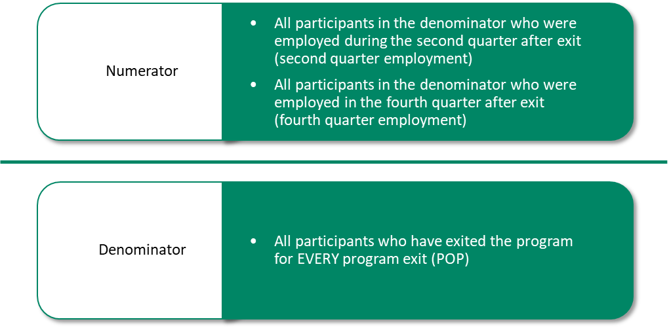

Median Earnings
- The median earnings in the second quarter after exit measures the median quarterly earnings of participants who are in unsubsidized employment during the second quarter after exit from the program.
Unlike other WIOA indicators, the median earnings indicator is not collected on individuals but is calculated from a distribution of all quarterly income earned by participants employed in the second quarter after exit.

Calculation of Median Earnings
To calculate the quarterly median earnings of participants included in the indicator, organize the range of values (lowest to highest or vice versa), and select the middle number as the median quarterly earnings value. Include the earnings of participants for each PoP in creating the distribution. When there are an even number of values, compute the value that is halfway between the two middle values. For example, if there are 100 values, the median would be the value computed between the 50th and 51st value. Exhibit 2 illustrates an example of calculating median quarterly earnings.
Note that if a data match results in $0 wages for a participant, that participant should not be considered employed and thus should not be counted in this indicator. Such participants also should be counted as not employed in computing the second quarter employment indicator. However, if a participant in a survey declines to provide earnings but claims to be employed, quarterly earnings should be recorded as $1.00 and should be included in the median calculation.
Exhibit 2. Calculating Median Quarterly Earnings
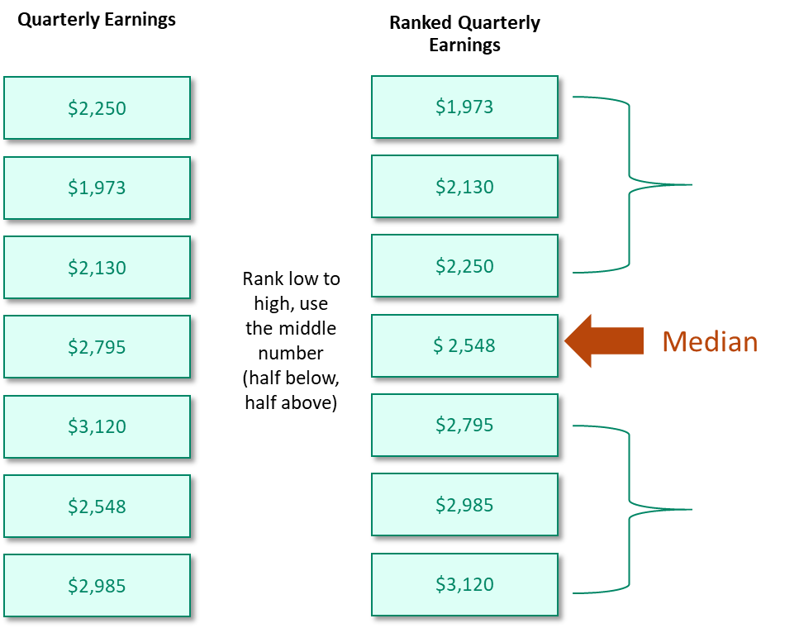

Credential Attainment
Credential attainment includes the achievement of a postsecondary credential or a secondary school diploma or its recognized equivalent during participation or within one year after exit from the program.
- Only participants who are dually enrolled in adult education and a postsecondary course of study and who exit from the postsecondary component are included in the postsecondary credential cohort of this credential.
- Only participants who enter adult education without a secondary credential or equivalent and who were in a secondary course of study in adult education and exited, are included in the secondary credential cohort for this credential.
- To count receipt of a secondary diploma or its recognized equivalent as a successful outcome, participants must enter postsecondary education or training or be employed within one year after exit.
The credential indicator is complicated because it includes two credentials, each applying to different cohorts or types of participants. The rate is based on a consolidated count of participants and successes for each of the two credential types. Participants who obtain both credentials should be counted only once per PoP, as a single success in the numerator, and participants who are in both cohorts should only be counted once in the denominator, per PoP. Like the other indicators, states must report on this indicator for each PoP.

Calculation of the Credential Indicator
To calculate this indicator, include in the denominator all participants who are in both cohorts. That is, (1) participants who are dually enrolled in adult education and a postsecondary course of study and who exit from the postsecondary component; and (2) participants who enter adult education without a secondary credential or equivalent and who were in a secondary level course of study in adult education and exited. However, a participant would count only once per PoP, even if the participant is in both cohorts.
Among participants who are included in the denominator, calculate the numerator by including all participants who achieved a postsecondary credential while enrolled or within one year of exit and all participants who achieved a secondary credential while enrolled or within one year of exit and who also were employed or entered postsecondary education within one year of exit. Count only one credential per PoP.
Exhibit 3 illustrates the calculation of this indicator.
Exhibit 3. Calculating the Credential Indicator Rate
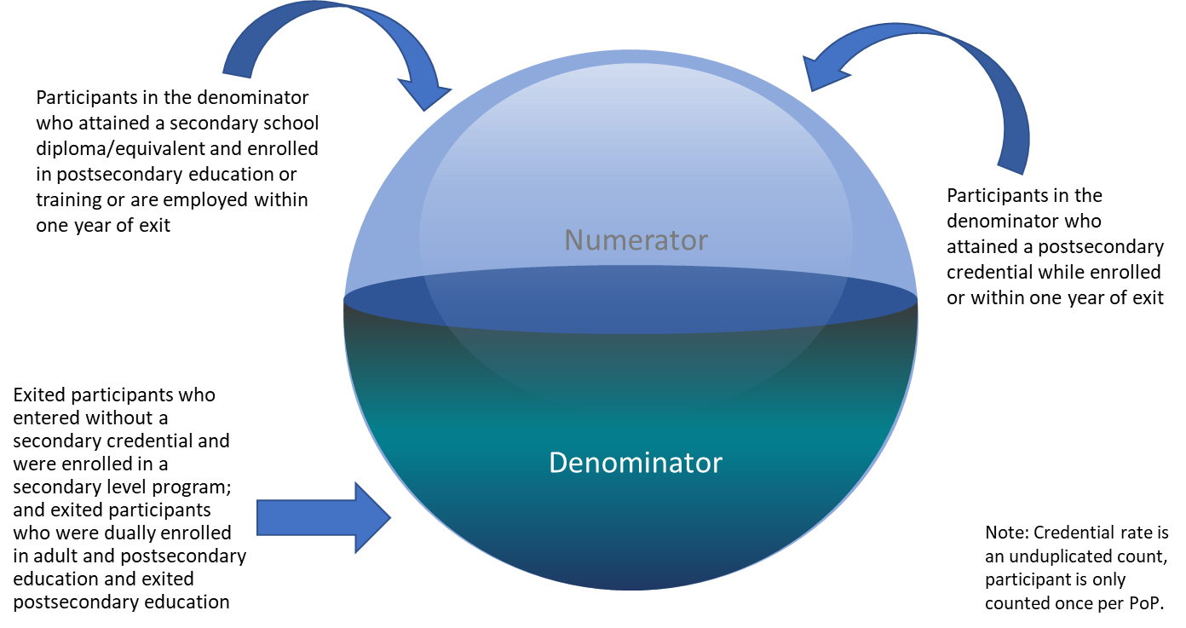

The Impact of Missing Data in Indicator Calculation
WIOA provides no allowance for missing data or low response rates. As is evident from the calculation procedures presented in this section, all participants to which the indicator applies are included in the denominators and achievements are included in the numerators. Calculation using missing data means that achievement rates will be suppressed. For example, if only 50 of 100 participants provided SSNs for an employment data match, and 25 of them were employed during the second quarter after exit, the employment rate would be 0.25, or 25%. All of the 50 missing participants would be counted as unemployed; however, the actual employment rate is likely higher because some of the missing participants probably were employed.
Collecting SSNs is difficult for many states because education agencies have typically not been required to collect them. In addition, privacy concerns inhibit data collection and reporting by participants and program staff alike, and participants who are undocumented do not have SSNs. However, since data matching using participants’ SSNs is the main method used by states to determine employment, obtaining a higher percentage of SSNs is critical to the validity of the employment indicators data. Performance calculations will be adversely affected when a large proportion of exited participants are without SSNs.
States have the option of collecting employment data using supplemental data collection methods, including a survey, which is the most common collection method (See OCTAE Program Memorandum 17-6 in the NRS TA Guide at https://www.nrsweb.org/sites/default/files/NRS-TA-January-2018-508.pdf). Conducting a survey poses its own challenges, however, chiefly because of the burden it places on local programs to collect the data. Local program staff often lack the expertise and resources needed to conduct a survey, and the time lag from program exit until the data are collected is an additional hurdle.
Another source of missing data, especially relative to credential attainment, is incomplete coverage in databases for postsecondary entry and completion. No single source is comprehensive, and states must rely on multiple sources to obtain these data. The lack of complete data from databases reduces the number of successes that states can determine; that is, the numerator in the calculation is smaller than would be the case if complete data were available.
We return to these issues in Section 4 of this guide, which discusses strategies for reducing the number of missing SSNs and for collecting data using surveys.

3. Steps for Collecting Postexit Employment and Credential Indicators
To collect the employment and credential indicators accurately, states need to identify the participants for whom the indicator applies and collect the requisite data at the appropriate time. As described in the previous section, this process is complicated due to the different requirements for each indicator, especially for the credential indicator. In this section, we provide a four-step approach that includes identifying the participants for each indicator, determining the time period for collecting the data, the process of data collection, and reporting activities. We break each step down into its essential components. Your state may differ in the order in which it performs the steps or the components within each step. In the end, however, you will have the same information to track participants and calculate the indicator.

Step 1: Create the Participant Pool for Each Indicator (Denominators)
This step involves identifying the entire group or pool of participants to which each indicator applies. Note that you may need to collect more than one indicator for some participants and, consequently, the same participant may be in more than one pool. In addition, you must identify participants for each PoP in which the indicator applies so that the same individual could be included more than once in the pool.
For all postexit indicators, create a pool of participants using the following criteria:
- Include only participants who exited during the program year along with their exit date.
You should collect the postexit indicators only after the participant has officially exited; that is, after at least 90 days have elapsed without receiving services and with no further services are scheduled. You must know the exit date from each PoP to identify when to collect the indicator. You also need the exit date to know which indicator to track for each time period, as described later in this section.
- Include participants for each PoP.
You must collect the postexit indicators for participants after exit from each PoP. This means you could collect data on the same individual more than once, according to the appropriate time periods for the indicators. For example, if there are 100 participants who exit and 10 of these participants had a second PoP, the total number in the pool for data collection would be 110 and you would need to collect data twice for the 10 participants with a second PoP.
- Identify the age, sex, race/ethnicity, and barriers to employment of participants for each PoP.
On the statewide performance report (SPR), you must report indicators by participant demographic characteristics, including all of the barriers to employment information. As you create your participant pool, tie these demographic data to each participant for each PoP.
- Exclude participants in correctional education (Section 225) who remained incarcerated (OCTAE Program memo 17-2, Attachment 2C) and participants who exited due to identified exclusions (OCTAE Program memo 17-2, Attachment 2A). (see NRS TA Guide at https://www.nrsweb.org/sites/default/files/NRS-TA-January-2018-508.pdf).
WIOA does not require you to collect the postexit indicator data on incarcerated participants and participants excluded by WIOA-identified reasons, such as entering military service, long-term illness, or death.
Following these procedures will produce a pool in your database of all exited participants for each PoP, except those excluded, with their exit date and demographic information. Exhibit 4 illustrates the creation of the pool.
Exhibit 4. Participant Pools for Indicator (Denominators)
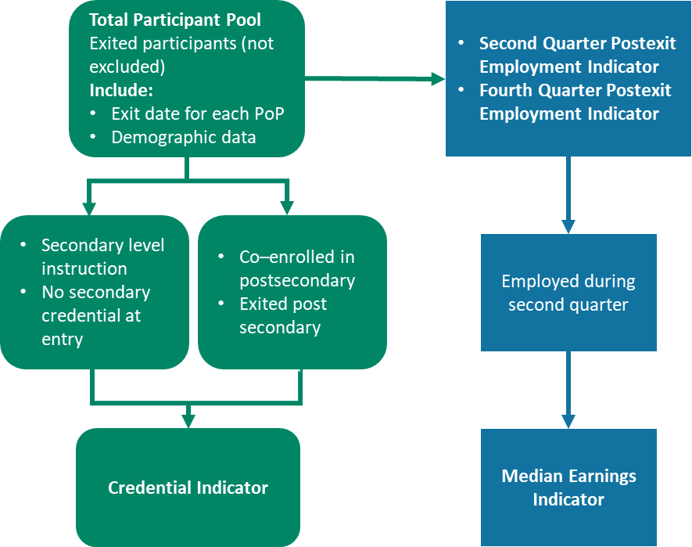
Next, identify participants in the pool for each indicator.
- Employment Indicators
  - Second quarter employment and fourth quarter employment: Include for both quarters all exited participants in the pool for each PoP.
  - Median Earnings: Include only exited participants who were employed in the second quarter after exit for each PoP.
- Credential Attainment
  - Secondary credential: Include from the pool all participants who exited from adult education who did not have a secondary credential upon entry and who were enrolled or advanced into a secondary course of study.
  - Postsecondary credential: Include from the pool all participants who were co-enrolled in adult education and a postsecondary course of study and who then exited the postsecondary program within the program year reported. Do not include participants who did not exit from the postsecondary program of study.
Some participants could be included in both the secondary and postsecondary credential component of this indicator. For example, a participant without a secondary credential could be in a secondary-level course of study in adult basic education (ABE) and co-enrolled in a postsecondary education program. However, participants are counted only once per PoP for the credential indicator calculation. Consequently, for each PoP, a participant in both credential groups should be consolidated and reported as a single participant (i.e., “1”) for the credential rate indicator denominator. For each PoP, all secondary and postsecondary achievements for a participant should be consolidated and reported once (i.e., as “1”) for the credential rate numerator (see Step 3), even if the participant achieved both types of credential.
After you have completed the procedures in this step, you will have the total number of participants for each indicator, which will be the denominator for calculating each indicator. Remember that each participant is counted for each PoP in these denominators.

Step 2: Determine Time Periods for Data Collection
Collecting postexit indicator data is complicated by the different time periods to which the data are tied. This means you must identify which time periods apply to each participant for each indicator and keep track of the time to collect the data. The employment indicators are tied to calendar quarters according to the participant exit data. The credential indicator, although not tied to quarters, must be collected within one year of exit.
Exhibit 5 summarizes the data collection schedule for each indicator by exit quarter and quarter in which data collection would occur. As an example, the exhibit shows the schedule for the 2018 Program Year (PY), reported on October 1, 2019.
The exhibit reveals three complications in determining the time period for data collection:
- The second quarter employment and median earnings indicators follow a program year timeline (July 1–June 30) but for the previous PY. In the example, participants who exited in PY 2017 will be reported in the PY 2018 report, due October 1, 2019.
- The fourth quarter employment indicator covers two program years—the second half of PY 2016 and the first half of PY 2017—in this example, and thus follows a calendar year timeline. Therefore, some participants included in this indicator have exited two program years before the reporting date.
- The credential indicator follows the same calendar year timeline as the fourth quarter employment indicator. It, too, covers two program years (in this example, the second half of PY 2016 and the first half of PY 2017), and some participants included in this indicator have exited two program years before the reporting date.
Exhibit 5. Data Collection by Indicator and Exit Quarters, for PY 2018 (Reporting on October 1, 2019)
Indicator | Participant Exit Quarter and Date Range | Collection Quarter and Date Range
Second Quarter Employment and Median Earnings | First Quarter PY 2017  (July 1–September 30, 2017) | Third Quarter PY 2017  (January 1–March 31, 2018)
 | Second Quarter PY 2017  (October 1–December 31, 2017) | Fourth Quarter PY 2017  (April 1–June 30, 2018)
 | Third Quarter PY 2017  (January 1–March 31, 2018) | First Quarter PY 2018  (July 1–September 30, 2018)
 | Fourth Quarter PY 2017  (April 1–June 30, 2018) | Second Quarter PY 2018  (October 1–December 31, 2018)
Fourth Quarter Employment | Third Quarter PY 2016  (January 1–March 31, 2017) | Third Quarter PY 2017  (January 1–March 31, 2018)
 | Fourth Quarter PY 2016  (April 1–June 30, 2017) | Fourth Quarter PY 2017  (April 1–June 30, 2018)
 | First Quarter PY 2017  (July 1–September 30, 2017) | First Quarter PY 2018  (July 1–September 30, 2018)
 | Second Quarter PY 2017  (October 1–December 31, 2017) | Second Quarter PY 2018  (October 1–December 31, 2018)
Credential Attainment | January 1–December 31, 2017 | While participant is enrolled or up to one calendar year from exit date; for participants who obtained a secondary credential, you must also obtain employment or postsecondary entry from exit date up to one calendar year later.
The time lags are due to the long follow-up period for the postexit indicators (up to one year after exit) and to accommodate for the time it takes for participant records to appear in data bases used for matching. Exhibit 6 summarizes the exit time periods for each indicator.

Exhibit 6. Participant Exit Periods for Reporting Postexit Indicators
Indicator | Participant Exit Period | Participant Exit Period  For PY 2018 Reporting (due October 1, 2019)
Second Quarter Employment | Program Year, One Year Previous | July 1, 2017–June 30, 2018  PY 2017
Median Earnings | Program Year, One Year Previous | July 1, 2017–June 30, 2018  PY 2017
Fourth Quarter Employment | Calendar Year, Two Years Previous to Report Date | January 1, 2017–December 31, 2017  (Last Two Quarters of PY 2016 and First Two Quarters of 2017)
Credential Attainment | Calendar Year Two Years Previous to Report Date | January 1, 2017–December 31, 2017  (Last Two Quarters of PY 2016 and First Two Quarters of 2017)

Step 3: Collecting the Data to Determine Achievement for Indicators (Numerators)
The two previous steps described the process for identifying the pool of participants to create the denominators for each indicator and the time period in which to collect each indicator. This third step summarizes the process for collecting the data for the indicators to determine participants’ success in achieving the outcome. You must collect the outcome data for each PoP, meaning that participants who achieve an outcome in each PoP will be included multiple times.
The number of achievements or successes will be the numerators for calculating the indicators. States collect the data through data matching, supplemental methods including surveys, or some combination of these methods. The use of supplemental data collection methods is especially important for states that are confronting large proportions of missing SSNs. Section 4 of this guide provides greater detail on survey and supplemental methods.

Employment Indicators
- Although states report the SPR and NRS tables annually, it is advisable to run the data match for the relevant participant pool by quarter according to Exhibit 5. More frequent data matching will allow states to correct errors and other anomalies on a timely basis. The resulting match will provide the number of participants employed in the second and fourth quarters for reporting.
- For surveys and other supplemental methods, it is highly desirable to collect second and fourth quarter employment data on a monthly basis, according to the exit date ranges. If the survey is conducted less frequently, the amount of missing data is likely to be greater because staff may be unable to locate participants or participants may not recall information.
- For median earnings, obtain quarterly second quarter earnings of all participants in the relevant pool for each PoP through data match or supplemental methods and calculate the median value. This indicator is a type of average of the distribution rather than an individual achievement of any individual participant.
- Link demographic data (age, sex, race/ethnicity) and barriers to employment for each participant for PoP for each employment outcome.

Credential Indicator
Collecting data for the credential indicator differs by type of credential. For credential attainment, you can use data matching or surveys to obtain the number of participants from the relevant pool who achieved a credential. Although few participants will achieve more than one credential in a year, you must collect the outcome data for each PoP. Participants who obtain a credential in each PoP will be included multiple times.
- For participants who achieved a secondary credential, count only the number of participants who obtained employment or entered postsecondary education from exit date up to one calendar year later. If a participant obtains a secondary credential but is not employed or did not enter into postsecondary education within one year, this outcome cannot be counted in the numerator for this credential.
- Link demographic data (age, sex, race/ethnicity) and barriers to employment for each participant for PoP for each achievement.
- Record the number of postsecondary credentials achieved and the number of secondary credentials achieved with accompanying employment or postsecondary entry for NRS Table 5. For the SPR, record only one achievement per participant per PoP.

Step 4: Reporting Results
In the final step of the reporting process, states enter achievement data into the state adult education data base for each indicator. While states report postexit indicator data annually, states should collect data on an ongoing basis, such as monthly or quarterly, so that data quality can be continuously verified, and errors can be corrected. For example, missing data can be identified and obtained.
By October 1 of each year, states must report their data to OCTAE using its data portal, which has three data entry templates: the SPR, the NRS tables and the MSG table.

SPR Template
- States first upload data into the SPR template, which includes all WIOA indicators and additional information.
- Indicator data in the SPR include the number of participants in the numerator and the denominator.
- The SPR requires a disaggregated breakdown of indicators by participant demographics and barriers to employment.

NRS Tables and MSG Template
States must upload data into the NRS tables and the MSG template.
- While only a single credential per PoP for the credential indicator is reported in the last row of Table 5, states must disaggregate the credential indicator achievements into participants who achieved a postsecondary credential and those who achieved a secondary credential outcome or its recognized equivalent in the table. The number of participants who achieved the secondary credential outcome are further disaggregated into those who achieved a credential and subsequently either entered into postsecondary education or were employed within 1 year of exit. This disaggregation is reported separately on NRS Table 5.
- As noted earlier in this section, the postexit indicator data is reported for a different time period than all other data in NRS tables. NRS tables report all data on the previous program year except the post-indicator data. These indicators are reported for participants who attended one or two years earlier, as shown in Exhibits 5 and 6.
The OCTAE data portal includes consistency checks that automatically identify errors. States cannot submit data that do not pass the checks. OCTAE staff reviews data submissions and notifies states if there are inconsistences or other issues.

4. Strategies for Improving Data Quality
As demonstrated in the review of the indicator calculation procedures presented in Section 2 of this guide, all participants for whom the indicator applies are in the denominators, and achievements are in the numerators. Calculation using missing data means the achievement rates are suppressed. Data matching is the most efficient and accurate way to collect postexit data but for the employment indicators, this procedure requires having participants’ SSNs. When SSNs are omitted from student records, data matching is usually impossible for determining employment. This section details challenges in obtaining SSNs and collecting postexit indicator data and describes potential strategies states and programs can use to address them.

Challenges Obtaining Social Security Numbers
Several factors create challenges to obtaining SSNs. First, providing an SSN is not required to participate in adult education, so even when local programs ask participants to provide SSNs, there will always be missing numbers in data records due to refusals. There also may be state legal or policy prohibitions relative to collecting SSNs, as well as privacy concerns among local providers and participants. In addition, many students who are English-as-a-second language (ESL) learners—some of whom may be undocumented—often do not have SSNs. Those and other participants also may not have SSNs, may not remember them, or may provide incorrect SSNs.

Strategies for Obtaining Social Security Numbers
Because there will always be some missing SSNs, states must use supplemental methods (described later in this section) to collect the data. However, strategies focused on both staff and participants can increase the number of SSNs collected.

State Policy and Training
States can set the tone by emphasizing the importance of collecting SSNs to local program staff through policies and professional development. Program staff should be convinced that complete student data records are essential. Local staff may not fully understand the importance of the postexit indicators and the vital role of SSNs in data collection. States can convey that message in multiple ways, including: staff orientation, webinars, and repeating the message at professional development sessions and state conferences. Training for local staff also should include methods of collecting SSNs from participants and ways to sustain participant contact.
Another way states can emphasize the need to obtain SSNs is by setting targets for the percentage of SSNs collected by programs, monitoring compliance, and tying targets to incentives or sanctions. Just as states set targets for pre-and posttesting rates, setting a target for the percent of SSNs collected will create a tangible goal for programs and, when backed by rewards or incentives for reaching targets, can be a powerful motivator.
New York state uses this approach and monitors local program progress towards targets, through reports in the state database of the percentage of participants who have provided SSNs. Using this information, the state NRS data coordinator identifies local providers that are struggling in their collection efforts and explores with the program possible reasons why the programs is challenged. For example, the program may have a large percentage of ELLs, its data may be negatively influenced by poor collection procedures, or its staff may have privacy concerns for participants. With this information, the state targets technical assistance to the specific programs and staff to boost the SSN collection rates.

Participant Contact and Followup
We live in a time of high concern about threats to privacy and the dangers of providing our SSNs to others. Participants share these concerns and often may be reluctant to provide their SSNs unless they understand the reason for collecting them and how they will be used.
Program staff should not assume that participants trust and accept the reasons for asking for SSNs and should inform them at intake why collection is important. It is important to frame the explanation in ways that highlight benefits to participants (e.g., the program needs the information to demonstrate its success in helping students; the data are needed to maintain funding). Program staff also must be persistent in trying to collect SSNs for as many participants as possible and should not tolerate missing data. A multifaceted approach using both technology and personal contact can do much to increase the number of SSNs collected from program participants. A local program in Nevada, for example, used the following approach to collect participant SSNs.
- Immediate electronic collection of SSNs. The program implemented online registration that collected SSNs through the website, the students’ first contact with the program.
- SSNs recorded at program orientation or the first in-person session. If the participant does not provide an SSN during the online registration or did not register online, staff explains its importance during orientation and asks for the SSN again at that time.
- Follow-up upon enrollment. If a student achieves 12 contact hours but still has not provided an SSN, staff ask for it again.
- Follow-up at time of assessment. Staff request missing SSNs when students are tested.
- Phone surveys after exit. Staff conduct follow-up calls to collect the requisite information from participants who exit the program and still have not provided SSNs.
Using this approach, the program increased its rate of SSN collection from approximately 50% to more than 70% of participants (see https://www.nrsweb.org/sites/default/files/Collecting-Data-Practice-508_0.pdf).
Exhibit 7 summarizes strategies for collecting SSNs.
Exhibit 7. Strategies for Improving Collection of SSNs
- Make collecting SSNs a state priority:
  - Set target percentages for local providers.
  - Monitor collection of SSNs through data system reports
  - Offer incentives for meeting and/or sanctions for failing to meet targets.
- Provide professional development to staff on reasons for and importance of collecting SSNs and postexit indicator data.
- Understand why providers and/or participants are not providing SSNs:
  - Analyze programs and students. Who (participants and staff) is not providing SSNs and why.
- Inform participants about why SSN collection is important:
  - Frame the message in a way that highlights benefits to participants (e.g., improved funding, demonstrate benefits of program to future participants).
- Ask for SSNs often; e.g., at enrollment, during enrollment, at exit, after exit.

Other Types of Participant Identification Numbers
Some states are developing and using other types of identifiers to track participants. One approach involves combining a participant’s name, birthdate, and zip code to create a unique number. By coordinating with other agencies, it may be possible to use these identifiers in conjunction with some education, postsecondary, and state longitudinal databases. However, SSNs remain the only identifier for matching records in unemployment insurance (UI) databases.

Data Matching

Challenges in Data Matching
Having participant SSNs is only one step in obtaining participant achievement data through data matching. States must establish data sharing agreements among their agencies to obtain employment data matches and to access postsecondary data sources. Each agency has its own privacy and confidentiality policies, data formats and record layouts, and data reporting and collection schedules. Data sharing agreements must address these differences and describe common data definitions, data input and reporting formats, and cost so that data can be integrated into different systems. This requires negotiation, cooperation, and modifications to data systems.
Even when data record alignment issues are addressed, there are other challenges involved in tracking students. There is a time lag of up to two years that makes it difficult to account for students who are transient within their communities. The time lag for obtaining data is one reason for the delay in reporting that was described in Section 3.
In addition, tracking participants who move across states poses challenges relative to collecting employment and wage data, especially in metropolitan areas with multistate borders. Interstate employment databases, such as the U.S. Department of Labor’s Wage Record Interchange System and the forthcoming State Wage Interchange System (SWIS) allow wage data matching for states that develop data sharing agreements in order to participate in the system.

Data Sources for Postsecondary Credentials
In most states, the UI database is a readily available source of data matching for obtaining participant employment status and wages. While the interface does not provide complete coverage of all participants, it is a single source of employment data that is sufficient in most states.
The database options are more complicated for the credential indicator. For the secondary credential, the state agency or external testing vendor that administers the secondary credential test can identify participants who have passed the tests and received the credential. However, there is no single source for data matching to determine whether participants obtained a postsecondary credential or have enrolled in a postsecondary program. Obtaining this information requires accessing multiple data sources to gather these outcomes.
States can establish data sharing arrangements with their community college systems as one source of data, and developing this agreement is simplified in states in which adult education is part of the community college system. For national-level data, the National Student Clearinghouse is a strong option, and some states also obtain data from the Institute for Higher Education Policy. Other possible data sources include the Integrated Postsecondary Education Data System and federal student aid data. At the local level, programs can develop data sharing arrangements with local community colleges and other postsecondary service providers in their communities.

Supplemental Data Collection
Despite best efforts, there will always be some percentage of missing SSNs because some participants will not have a number or will not provide it or because the SSN is invalid due to errors in reporting. In addition, not all employment is included in UI databases or the state may be unable to data match. It may also prove to be impossible to obtain postsecondary credential attainment because there are no databases available with this information. To address these cases, states may use supplemental data collection methods as described in OCTAE Program Memorandum 17-6 (see NRS TA Guide https://www.nrsweb.org/sites/default/files/NRS-TA-January-2018-508.pdf). The most common supplemental method states use is a survey of participants.
Conducting a survey is more time- and resource-intensive than running data matches for employment, wages, and credential information. It requires developing survey questions and protocols and collecting the data, with care taken to frame and deliver questions in a manner that does not bias responses from participants. Surveys need to be translated into several languages, and multilingual survey administrators must be available. Surveying participants after they exit the program calls for specific skills to design and administer surveys and may require additional training for program and state staff.

Strategies for Improving Data Collection Through Surveys
In addition to the overall burden of time and resources needed to conduct a survey, the greatest challenge confronting local programs stems from the effort needed to track participants after they exit the program. Adult education students are especially transient and difficult to locate. The time lag inherent in the WIOA indicators further complicates tracking of participants because participants are not surveyed until several months after program exit. Missing participants lowers the survey response, which, in turn, reduces the survey’s validity.

Participant Contact Information
Just as participants should understand the need for programs to collect SSNs, they should know that the program may contact them about their education and employment status after they exit the program. Local program staff should explain to participants at entry that they may be contacted and should clarify the reasons for this contact. Staff should emphasize the importance of staying in touch and should note that the collected information is needed for the program’s funding and to determine the program’s effectiveness in helping students.
Program staff should collect complete contact information (e.g., phone, address, e-mail, social media handles) for both the participant and his or her family members at program entry and should update that data throughout the participant’s tenure in the program. Students should receive frequent reminders that their information must remain current and that it should be updated as necessary during enrollment. After exit, programs should continue to contact participants though email or snail mail to update contact information.

Data System Reports for Tracking
An essential tool for tracking participants is to have program data system reports of exited participants that include all contact information, dates of exit, which indicators apply to the participants, and when staff should contact them again. Staff should review and update contact information regularly. Ideally, the data system also should be able to track when staff last contacted participants and should have the capacity to record survey responses. The database should be structured to easily aggregate survey data with other NRS state data.

Reducing Burden: Programs
As discussed in Sections 2 and 3 of this guide, states must track every participant (except those subject to exclusions) for one or more of the postexit indicators. Absent data matching, there may be a substantial burden on local programs when there are many participants to survey. There are approaches that states can take to reduce this burden by limiting the overall number of participants to survey and by having an organized process for conducting the survey.
Conducting a survey may seem overwhelming when there are many participants and providers who must be included. Ideally, everyone should be included in a survey; but available time and resources may dictate that it is more cost-effective to target programs and participants most likely to respond or to reflect actual state performance more accurately. The first step to reducing burden is to identify the programs from which large proportions of SSNs are missing. Some programs may already have high percentages of SSNs for data matching, and you may choose to exclude them to conserve resources. Similarly, programs with fewer participants may not add significantly to state totals. Consider focusing on the state’s largest programs, from which data could possibly be gathered on a number of participants sufficient to affect the state’s performance on the postexit indicators.

Reducing Burden: Participants
While all participants are included in indicator calculations, it is likely that some will not have obtained employment or cannot be contacted. Recall, as discussed in Section 2, that all exited participants are included in the employment indicators and if you have no information on their employment status, they must be considered not employed. If you are willing to accept that some identifiable groups of participants are unemployed, you can focus resources on those who are more likely to be employed and thereby more accurately reflect your state’s employment indicators. One such group of participants who could be assumed as not employed are those who indicated their labor force status was “not in the labor force.” In most states, this figure can range from 20% to 30% of total participants. These individuals are unlikely to have obtained employment and if you are willing to report them all as unemployed, excluding them from the survey pool will reduce the survey burden.
You could also exclude any other categories of participants you have good reason to believe may not have achieved employment or credential outcomes. However, if you do so, bear in mind these participants must be counted as not employed or having obtained a credential. The advantage of so doing, however, is that you can direct your resources to focus on participants who are more likely to be employed or credentialed. For example, you could focus on participants who indicated they were employed at entry into the program. After exit, program staff can contact these participants at the appropriate time to determine whether they remained employed.

Reducing Burden: Survey Procedures
Limiting the number of programs and participants in the survey will reduce burden, but the approach and procedures used by local programs to conduct the survey can also minimize the time and resources needed. Setting goals for survey coverage will make the process more manageable. Using technology can allow programs to reach more participants with fewer resources and to achieve higher response rates, while effective organization will make procedures even more efficient.

Set Goals for Survey Coverage
The prospect of surveying hundreds or thousands of participants across multiple statewide programs and with limited resources is a daunting task, and program staff may feel overwhelmed and discouraged. The process is more manageable by starting small and setting goals regarding the number or percentage of programs and participants to include. The state can set these goals and develop a multiyear plan with an increasing number of programs and participants each year. Similarly, programs can agree on a target goal of reaching a set percentage of participants for the year.
By developing a plan with goals for increasing survey coverage over time, the state can establish a continuous improvement process to increase sample size. This approach also provides opportunities to learn over time what works to reach participants, to determine which programs have difficulty reporting, and to identify participants who are difficult to reach. States can then target resources strategically to plan and conduct surveys more efficiently. Local staff also will become accustomed to conducting surveys and can more readily integrate procedures into normal program operations.

Use Technology
Conducting follow-up surveys by telephone has been the most common method programs use to reach participants. However, local programs and states have begun using electronic platforms more regularly to reduce staff burden, which is substantial with telephone survey administration. Some states contact participants to complete the survey via text message or e-mail with a link to the survey. Other states have developed online applications so that participants can use cell phones, tablets, and other devices to complete the survey. These methods are much more preferable due to their reduced burden and the likelihood of higher response rates.
Using technology can be an effective way to reach students to conduct surveys to obtain postsecondary participation, credential and employment data. By automating the process, several steps can be accomplished with limited staff effort. Integrating the survey into the state data system is an efficient way to automate survey administration that can reduce burden. The data system must be able to generate the pool of participants who should be contacted, and the system can be programmed to determine when notifications should be transmitted. Staff will not have to monitor when communication is required. In addition, the data system can be made to integrate participants’ disaggregated survey responses back into their records. This automated recording reduces burden on program staff, who otherwise would have to enter survey response data manually.
The system can also automate Interactions with participants using communication modes such as e-mail, text, and social media so that those who are technologically oriented can be alerted and can submit information independently and without staff interaction, maintaining uniformity and reducing the need for staff hours to conduct calls. An automated electronic system can track all communications between participants and programs, recording contacts, successful collection of data, and needed follow-up.
Electronic methods, however, often cannot suffice without some personal contact. When staff prepare participants through frequent reminders during programming and follow-up check-in calls, participants are more likely to offer their personal information and to update staff on their progress. Communications should be translated into multiple languages to reach ESL participants.
California provides an example of using technology to aid in identifying program participant pools, disseminating surveys, and collecting survey responses. Exhibit 8 describes the state’s plans for its technological approach to administering surveys, which includes the features just described.
Exhibit 8. California’s Plans for Improving Data Collection with Surveys
The California Department of Education enhanced its adult education database to generate surveys automatically, deliver them to participants, collect the data, and produce reports. Within the system, a follow-up survey wizard flags students who have not participated for at least 90 days to create a survey sample. Based on contact information within the system, the wizard determines whether respondents should receive survey invitations via text, e-mail, or both. Students can receive invitations via cell phone, computer, or similar device. Invitations contain a link to a student portal where students enter their survey responses, which are then communicated to the data system. Each local program sends three invitations per student and staff then contacts those who have not responded by phone. Highlights:
- Automated systems. The state data system is programmed to generate information, identify and track the target student pool, initiate contacts with participants, send out and collect information, and track communications.
- Secure data. The student portal is located on a server that is separate from the data system but that communicates with the system through a secure application programming interface to protect student data.
- Familiarize students with the follow-up process immediately. All current students see the survey questions while they are enrolled so they know what to expect after they leave the program.
- Translate the survey. The survey invitations and questions currently are in six languages and more translations are underway.
- Increase student recognition and comfort level. Each local program can customize the invitation with program names, staff names, logos, and other features so that recipients know communications are legitimate.
- Track the outreach process. Each staff member can generate reports that identify which invitations were delivered, which were undeliverable, whether the survey was accessed, and whether it was completed.
- Minimal training needed. Local program staff were oriented to the process through webinars, and no additional training was needed.
- Test process before scaling up. Survey dissemination was piloted with 25 students.

Reducing Burden: Organize the Survey Process
Strategically targeting the programs and participants to survey, coupled with the effective use of technology, can substantially reduce the burden of conducting surveys. Nonetheless, programs may still need to conduct some telephone surveys of many participants. By planning and carefully organizing the survey process, programs also can minimize the time and resources needed to conduct surveys. Several steps are critical in developing and administering a survey in an organized way.
- Lay the groundwork. Inform students at entry and remind them during the program and when they exit that their contact information will be used to follow up after they leave the program. Let students know that family members may be reached to locate them, and employers may be contacted to determine their employment status and wages.
- Establish a schedule. Conducting the survey on a frequent, ongoing basis, such as monthly, will make the process more manageable, increase response rates, and cover the various postexit indicator milestones for students who exit at varying times throughout the year. Regular contact also helps ensure that the minimal time has elapsed since program exit.
- Identify the survey sample. Determine the applicable exit indicators and PoP exit dates and compile the contact information to be used. Keep in mind that all participants do not need to be surveyed for all indicators. Remember that participants must be tracked for each PoP.
- Develop a standardized survey questionnaire and administration process. Whether administered one-on-one with staff or virtually, the student experience should be the same; the questions posed, and the information presented and collected, should be uniform for all students in the state. The questionnaire should be brief to encourage completion.
- Provide training to staff for surveys administered by phone. Whether the survey is conducted by local staff, state staff, or a third party, the process must be uniform, unbiased, and clear so that participants can provide the necessary information. Guidance on how to conduct the survey will reduce inconsistent data collection.
- Set up virtual tools for electronic administration. If using an application or e-mailing the survey, ensure that the platform is user-friendly and functioning properly. Integrate the survey into your data system to automate administration, tracking and responses.
- Track the outreach process. Systematize the process so that all contacts, responses, and pending communications are tracked in a database to ensure efficiencies.
Following these steps will result in valid data for the postexit indicators, while using resources in the most efficient manner. See the NRS TA Guide, Appendix D, (https://www.nrsweb.org/policy-data/nrs-ta-guide) for more guidance on conducting a survey.
Exhibit 9 summarizes strategies for collecting data with surveys, and the Appendix includes sample survey questions for collecting postexit indicators.

Other Supplemental Methods for Employment Indicators

Employment Databases and Resources
OCTAE Program Memorandum 17-6 describes methods in addition to surveys that states may use to collect employment and wage data when data matching is not possible. In addition to missing participant SSNs, the lack of complete employment coverage within a state’s UI database makes supplemental sources necessary. Employment and wage data are not available for federal and military employees, for those who are self-employed, or for states that are not signatories to the SWIS. However, there are other sources of employment data that can be used for the employment indicators. Examples of these sources include:
- Federal employment records
- Military employment records
- U.S. Postal Service employment records
- State new hires registries
- State departments of revenue or taxation, employee/employer quarterly tax payment forms
- The Railroad Retirement System
- One-stop records on income-based program eligibility (e.g., TANF, SNAP)
- Data matching with other partners
Exhibit 9. Strategies for Improving Data Collection with Surveys
- Inform participants at enrollment, during enrollment, at exit, and after exit that a survey is coming.
- Maintain frequent contact—stay in touch with participants after exit:
  - Maintain reports in state database of exited participants by indicator.
  - Use community resources and networks to maintain contact.
- Implement incrementally:
  - Focus on larger programs, set goals.
- Reduce participant pool by identifying those unlikely to have achieved the outcome or to respond, e.g., automatically assume participants who are not in the labor force are unemployed, to focus resources on other participants
- Develop a brief survey
- Use technology:
  - Integrate the survey into the state data system
  - Use apps and social media

Individual Participant Records
Some databases may not hold the information needed, some cannot be searched without a participant SSN, and some have a too-long time lag on posting the data. Therefore, it may be necessary to access other sources of employment data that can be collected from individual participants:
- Self-employment records
- Income earned from commissions in sales or similar positions
- Copies of pay stubs
- Detailed and verified case manager notes
- Signed letter or other information from employer on company letterhead

Conclusion
The sections of this guide have provided a comprehensive review of the WIOA postexit indicators, including their definitions, how they are calculated, and the steps to follow for collecting and reporting them. In this section, we offered ways to improve the quality of data collection, focusing primarily on collecting SSNs and ways to conduct surveys of exited participants that minimize administrative burden and facilitate more complete data collection. Exhibit 10 provides a worksheet for assessing areas to consider when striving to improve your state’s data collection. By understanding the process and where you face challenges, you can use the approaches in this guide to collect more complete and relevant data for the postexit indicators. These indicators will allow you to demonstrate success in assisting participants to obtain employment and credentials.

Exhibit 10. Planning Worksheet for Collecting Postexit Indicators

Social Security Numbers and Data Matching

Need
What method do we currently use to collect SSNs at the program and state level?

What is the current need to improve collection of missing SSNs and other data? Is it a statewide problem, or is it specific to certain programs?

What are the reasons we do not have a higher rate of SSN collection? Is it because of state policy, legal barriers, student population, data collection procedures, entry practices, or similar issues?

Strategies
Are there local programs that are collecting SSNs and other missing data successfully? Can their approaches be used broadly across the state?

How best can programs prepare participants for the possibility of being contacted after they exit a program? How will we inform them that their employers or families may be contacted?

What level of effort by state and/or local programs will be required to collect SSNs? Is there staff outside of adult education who can assist in collecting this information, such as case managers?

Technology
What technology could we use to improve the rate of SSN collection?

What challenges do we have and how can we resolve them?

Data Matching

Data Sources
What databases will we use to collect postsecondary enrollment, employment status, and wage data?

How will we ensure that the same direct wage match record is used to determine both employment status and wages within a reporting period? How will we ensure that the same supplemental data is used to determine both employment status and wages? (Note that the same wage record match or supplemental wage information does not need to be used across reporting periods.)

How will we track data across multiple data bases?

Data Sharing
Do we have common data definitions and data input and reporting formats with other state agencies with which we share data? Do we need to improve our data sharing agreements with other state agencies?

What data sharing agreements do we need to access databases?

Data Collection Through Surveys and Other Supplemental Methods

Coverage
How will we identify participants to contact for missing SSNs? How will participants be segmented to align with postexit measures? Are there exit data for each PoP?

When the collection rates of select programs improve, will that improvement be sufficient to raise the overall state collection rate? Can we obtain this information from partners?

What supplemental data sources can we use?

Survey Design
What information do we want to collect in the survey? How will we ensure that we gather the following information for each participant?
Average hours scheduled to work per week; average number of hours actually worked per week; wage per hour; availability of paid leave; start and end dates of employment or continuing employment.

Who will design the survey and its delivery and administration protocol?

What are the language needs of our participants? How will we translate written materials? How will staff administer the survey so that the appropriate languages are covered?

Technology
What technology can we use to administer the survey?

Staff Training
What training will be needed for staff to conduct the survey?

How will we train staff to administer the survey?

Timeline
What timeline should we use to contact program participants so that we conduct follow-up as close to the reference period as possible? How will we collect SSNs and other missing data during the last month of the quarter and complete collection within three months? Do we need to collect follow-up data on a quarterly, monthly, or continuous basis?

Documentation of Outreach Efforts
Are there mechanisms in place that can be used to track outreach and the data collection process? Do we need to develop systems to do this?

Appendix. Sample Survey Questions

Employment

1. Since you stopped taking your adult education class, have you been employed in a paying job?
 Yes
If yes: What is your job and the name of your employer? _______________________________
When did you get a job? _______________________________
 No [Proceed to next section]

[Determine second post-exit quarter from response]

2. Thinking back to the three-month period between [specify second post-exit quarter months], did you have this or any other paying job at any time during those three months?
- Yes
- No [Proceed to Q. 4]
- DK/Refused [Proceed to Q.4]

3. Including this job and all jobs you may have had, how much money did you make during these three months?

Three-month total $_____________

(Obtain total or if the participant does not know, ask the appropriate questions below -up for each job]

How much did you make by the hour, week, month, or year?

$ __________ per __________ (hour)
How many hours per week did you work? ________
For how long? _________

$ __________ per __________ (week)
How many weeks did you work? ________?
For how long? _________

$ __________ per __________ (month)
How many months did you work? ________?

$ __________ per __________ (year)
How many months did you work? ________?
_______________________________
□ DK/Refused [Proceed to Q. 4]

4. Now thinking back to the three-month period between [specify fourth post-exit quarter months], did you have this or any other paying job at any time during those three months?
- Yes
- No
- DK/Refused

Secondary or Postsecondary Credential Attainment and Entry to Further Education

1. Did you receive any diplomas, certificates, or degrees, such as a secondary school diploma, from passing GED tests or a postsecondary credential or certificate, either while you were taking this class or since you took this class?
 Yes [Proceed to Q. 2]
 No [Proceed to Q. 3]
 DK/Refused [Proceed to Q. 3]

2. What type of diploma/certificate/degree did you receive? [Do not read choices to respondent. Check all that apply.]
- Secondary school diploma (i.e. high school diploma)
- Postsecondary credential or certificate necessary to obtain employment or advance within an industry or occupation
- Associate degree
- Bachelor’s Degree
- Other___________________
- DK/Refused

When did you receive that diploma/certificate/degree? [If more than one credential, obtain for all.]
Month __________ Year __________

OTHER EDUCATION AND TRAINING

3. Since you stopped attending the class or program, have you enrolled in any other educational or training programs?
 Yes
 No [End survey]

Where are you enrolled?
Other (Specify)_____________________________________________________

When did you start that program?
Month __________ Year __________

In what type of class or classes are you now enrolled? [Do not read choices. Check all that apply.]
 English Language Skills
 GED/High School
 Vocational/Job Training/IET
 Community College/College Level
 Citizenship  Family Literacy
 Other (Specify)_____________________________________________________
 DK/Refused

